ANNEX B
Cover Page for College to submit with PU2 H1 Maths End of year Examination Paper

Qn/No | Topic Set | Answers
1 | - Simultaneous equations  - Quadratic function | - x=2, y= -2 or x=4, y= -1  - 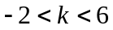
2 | Stationary points | 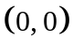, 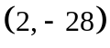, 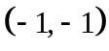
3 | Graphing techniques | 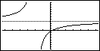
 |  | 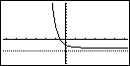
4 | Maximum and minimum | 175 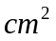
5 | Integration | - 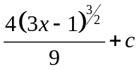, 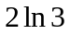  - 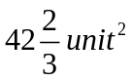
6 | Normal distribution & binomial distribution | 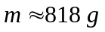, 0.0668
7 | Sampling | Quota sampling.  Quota sampling is biased/ unreliable.
Use stratified Sampling.
Select 25 PU1 students, 20 PU2 students and 15 PU3 students.
Use simple random sampling to select the required number of students from each level.
8 | Binomial distribution | 0.995, 0.519, 0.0375, 0.318
9 | Correlation & regression | 0.934, y = 0.914x + 20.4, x = 0.955y – 14.0  29.5, The estimate is unreliable as it is an extrapolation.
10 | Hypothesis Testing | 33.8, 146.5; p-value=0.0414, do not reject 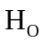.  there is no need to assume a normal distribution,  To reject 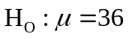, level of significance > 0.0414.
11 | Probability | The event  represents the case where the card taken is either a Heart, or a King, or both. 0.6.  The event 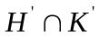 represents the case where the card taken is neither a Heart, nor a King. 0.4.  15/29, 0.5.
12 | Normal distribution | 100, 23.2.  0.391

